Contour Drawing
What is a contour drawing?
What is a blind contour drawing? 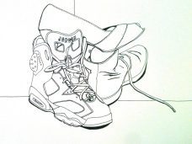
Why are we studying them?
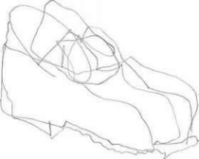

Blind Contour Drawing #1
Don’t look at the page and don’t lift your pencil.
Try to fill the page.

Contour Drawing # 1
Only edges of your subject but you can look and lift your pencil. Fill the page.

Blind Contour Drawing #2
Don’t look at the page and don’t lift your pencil.
Try to fill the page.

Contour Drawing # 2
Only edges of your subject but you can look and lift your pencil. Fill the page.

Shoe Contour Drawing

Line Project Brainstorm
Project Idea #1 | Project Idea #2
Project Idea #3 | Project Idea #4

Line Critique
Line Number:
Describe the types of lines the artist used.
Could the artist have used more variation in the types of lines? Were they creative and complex? Explain.
Does the artist fill the page to create a full and interesting work or is there something they could do to make it more complex?
Look at how the artist used ink to apply the lines. Are they smooth and consistent or does the artist need to slow down with their lines? Explain.

